Company name

Working here

Dear Danish Mustafa

Senior worker

Danish is a good and talented boy. He passed matriculation exams with good efforts. He is very hardworking boy. He gpt warm reception at his matric result . he recipt honour everywhere because it was the gretest success of his life.

He worked very hard in the same way in 1st year class . he wirked verfuy hard, and got good marks in his 1st year resut in the same way

He learn c++ language thoroughly and deeoly in 2nd year class . he increase his probleb solving skills very well

After inter part he started his dewlpment career in university life

*Signature here; 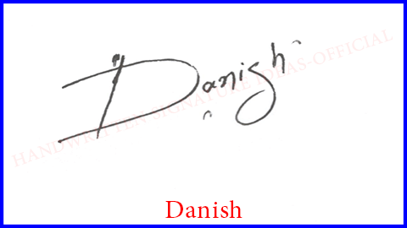*

*03071990167 www.example.com*

*address goes here Danish jajja86@gmail.com*